KUNAL DEMLA

CO4

102003088

LAB EVAL 21-03-22

Eucladian

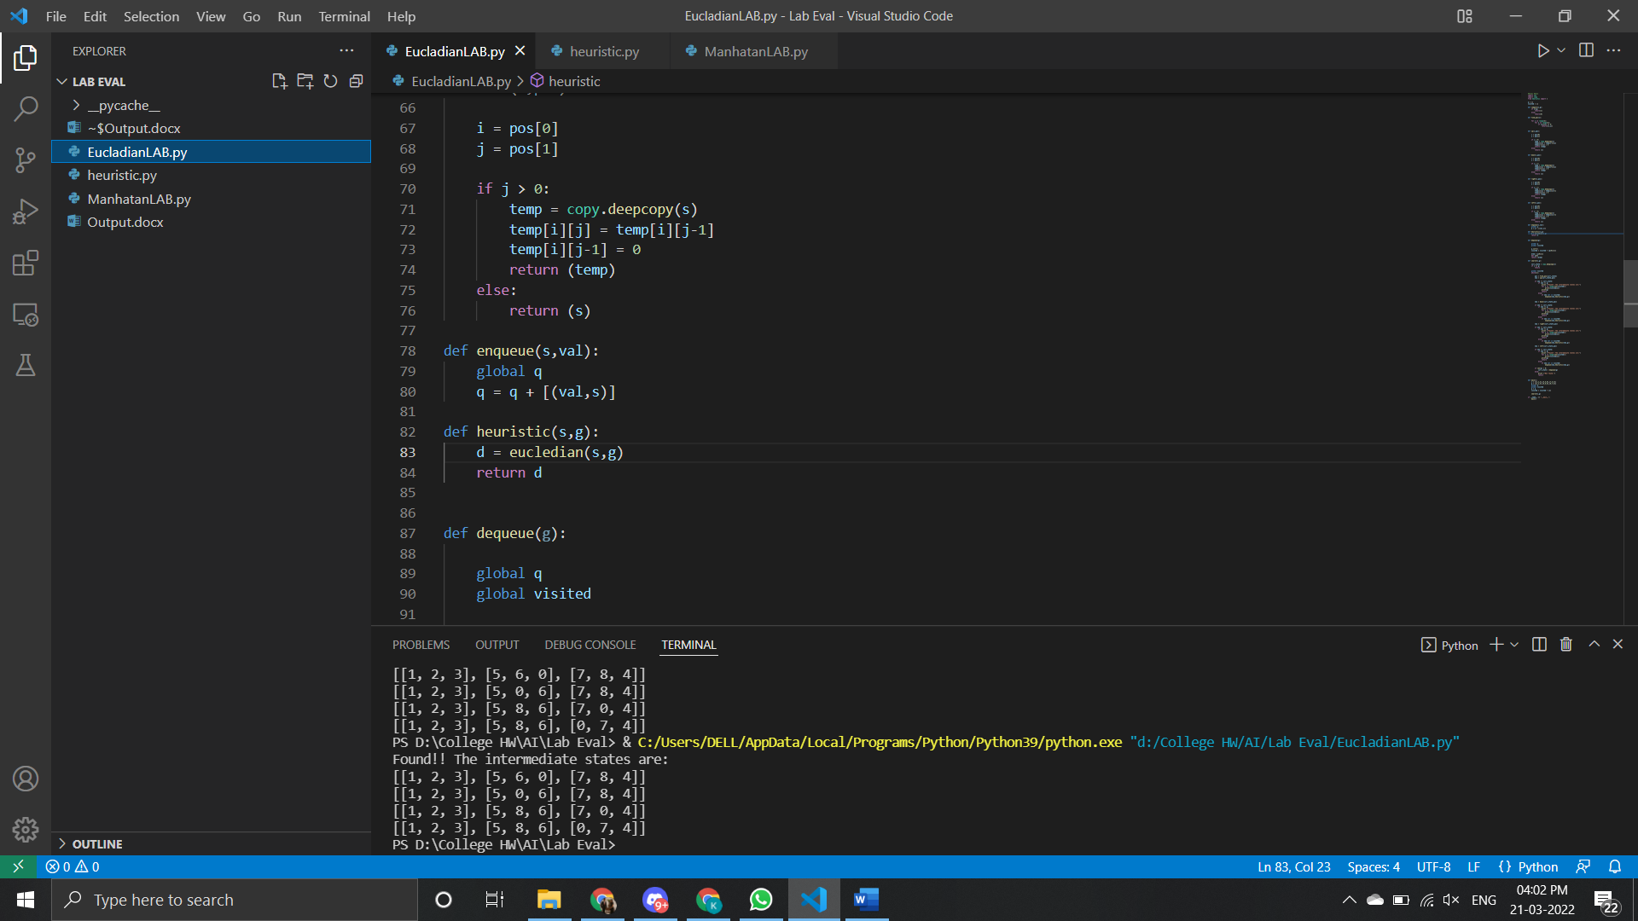

Manhattan

